# UI Concepts

Auditory Ace contains many different artistic choices that were made to better create an enjoyable experience for each user of the application. This documentation serves as a comprehensive guide, detailing the intricacies of the thoughtfully designed user interface (UI) and user experience (UX) elements that define the app's functionality. The team's commitment to creating a seamless and accessible interface is evident throughout the design, ensuring that users of all age groups can engage effortlessly in sound recognition practice. From the implementation of customizable settings to the strategic integration of gamification elements, this documentation provides an exploration of the design principles governing Auditory Ace's UI/UX, facilitating a thorough understanding for future development teams aiming to build upon and enhance the application.

## Color Choices

Auditory Ace used color-blind-friendly colors in its design so that more people would be comfortable using the app. Below are the RGB codes for each color option used in the application as well as their color names and where they were used in the design.

| RGB Code | Color Name | Usage |
| --- | --- | --- |
| 000000 | black | font and icons |
| a1d2f1 | baby blue color | background |
| daefda | white | containers on page |

## Fonts

Auditory Ace used the DM Sans 24pt Medium font choice in the screen designs. While exercises may use a different font depending on its theme, this font is the main font for the application.

## Icons

Icons can be found in the icons.zip file in the code database

Flash card icons used with credited permission from [2,414 Free icons of flash cards](https://www.flaticon.com/free-icons/flash-cards) .

## Screen Examples

Here are a few examples of what the early screens looked like for Auditory Ace.

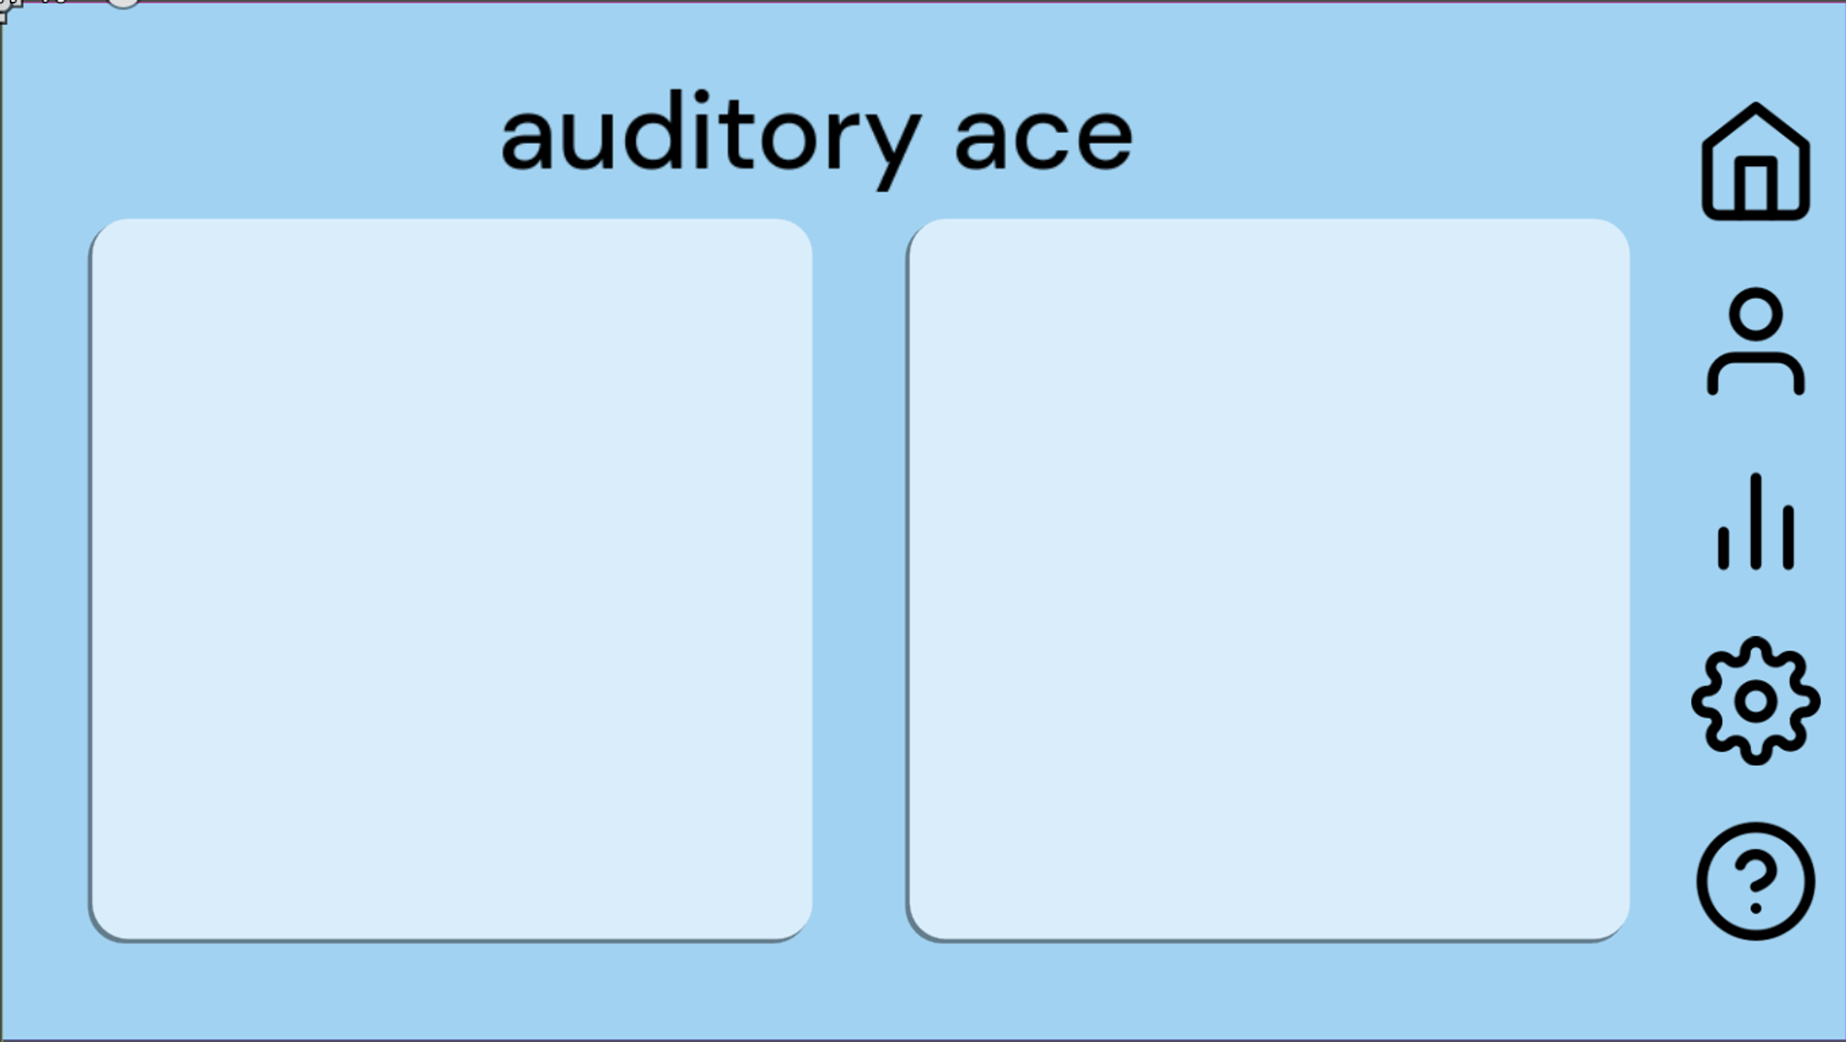

Home Screen

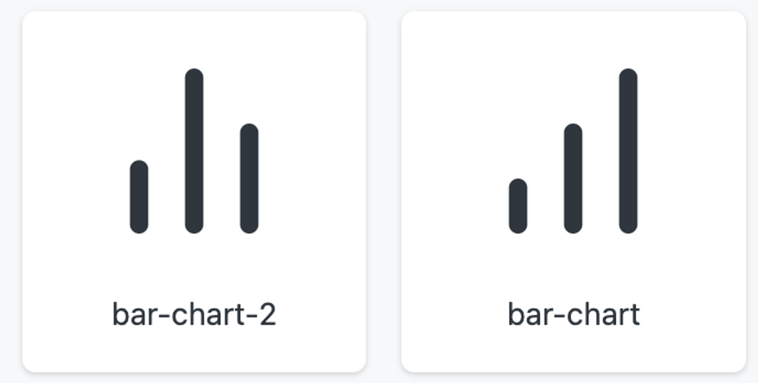

Statistics Charts